Consent form for using children’s art work / media on Cornwall Music Service Trust Website and Social Media

Dear Parent/Carer,
Your child has shown an interest in entering work for the Cornwall Music Service Trust Online Art Gallery.
We would like your signed permission in order to publish on our website, images of your child’s artwork. This may take the form of photos, film, typed documents or other digital media.
We would also like your permission to associate your child’s first name, their school name and their age, with their artwork. If the artwork is a reaction to a particular piece of music, please include the title and composer.
Consent : | Y / N
I give consent for my child’s artwork to appear on the CMST website and social media.
I give consent for my child’s first name to appear alongside their artwork.
I give consent for my child’s school name to appear alongside their artwork.
I give consent for my child’s age to appear alongside their artwork.

Artist’s name, School and Year Group:

Parent/Carer name :

Parent /Carer signature :

E-mail :

Phone Number :

Please e-mail to: art@cornwallmusicservicetrust.org (any queries to same address).
Thank you - we look forward to receiving your children’s creative contributions!
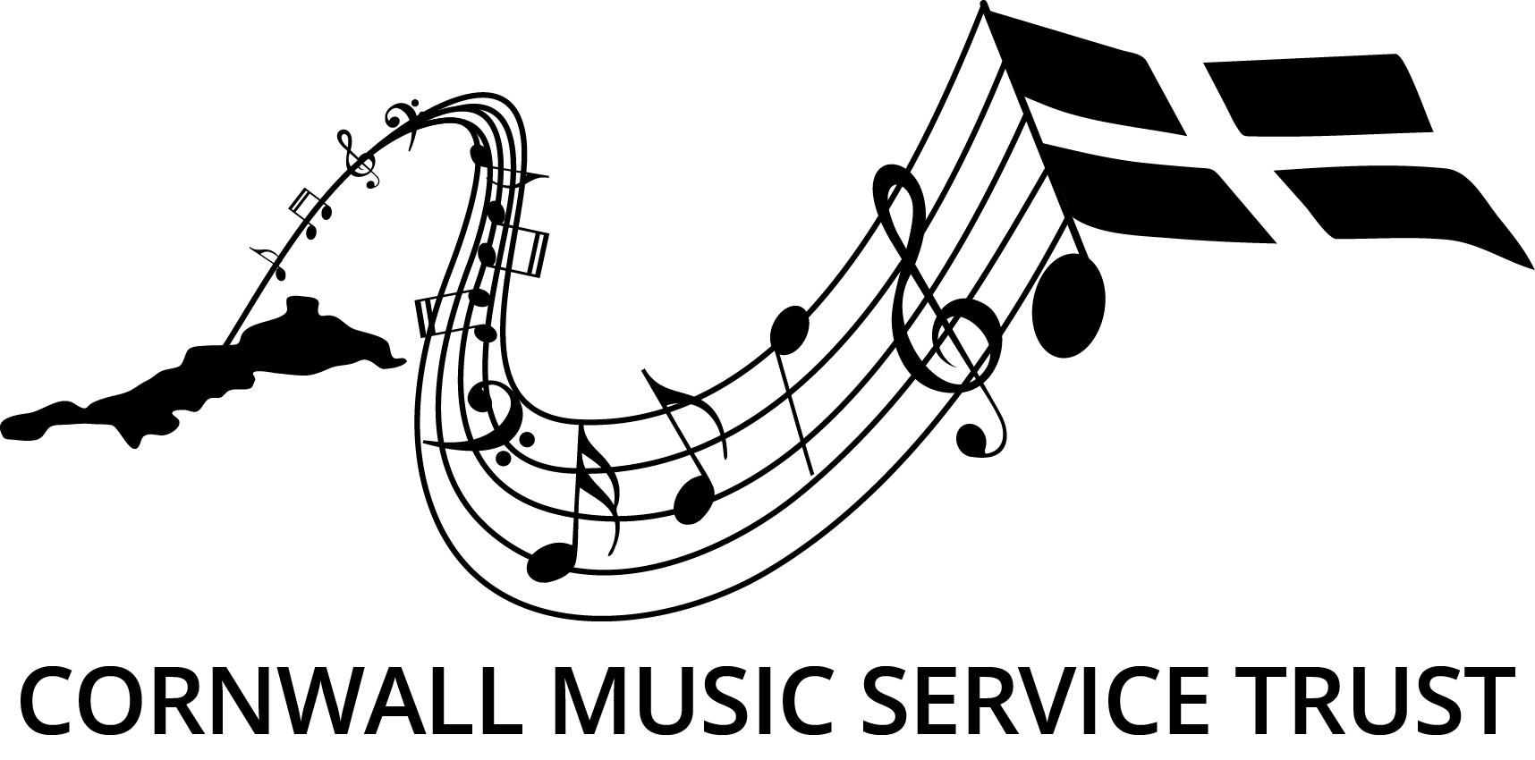
Patron: Charles Hazlewood

