CMST EARLY YEARS MUSIC INITIATIVE PILOT AND SOUNDWAVES EXTRA RESEARCH PROJECT.
CASE STUDY
Words by Ann Stott and Emily Garrod, with contributions from Vicki McNamara, Michelle Torres, Kara Parry and CMST Early Years Team.

'TO WHAT EXTENT CAN MUSIC SUPPORT COMMUNICATION IN AN EARLY YEARS SETTING?’

In July 2017 CMST secured funding to run a pilot research project in Cornwall, funded by Somerset based organisation Take Art and their Early Years branch Soundwaves Extra, through Youth Music funding. A pilot setting was identified from Early Years settings that took part in our survey and met with the criteria needed to fulfill the research project.

THE SETTING - PICCOLO NURSERY
Piccolos Early Years Group – Bugle School. Contrary to popular belief the setting was not chosen because of its musical names! It demonstrated particular need and was experiencing the impact of children with English as an additional language in it’s current cohort.
An area to research was collaboratively chosen and formed our question and project focus.
“To what extent can music support communication in an Early Years Setting?”

THE EARLY YEARS PRACTITIONERS
Miss Kara Parry
My name is Kara and a mum of 3 boys aged 19, 15, and 10. I have been working at Piccolo early years and within Bugle school since 2010. At the moment I work with the 3-4 year olds, and am a key worker to 10 children. I use the Statutory Framework (EYFS) Early Years Foundation Stage to help Plan and deliver activities that are fun and appropriate to the children’s interests and varying abilities whilst providing opportunity for challenge and development. I am then able to make detailed and sensitive observations for children within the setting.
Mrs Michelle Torres
I am a wife and a mum of two boys age 11 and 5. I have been working with children for the last 15 years,starting off as a group leader in a playgroup within the church hall. Unfortunately it had to close, due to lack of business, it was then taken over by Bugle CP School and was named Piccolo Early years Group. I was then taken on by the School and worked with a variety of different children starting from the age range of two up to 11 year olds. I am now within the Piccolos preschool working with 3 and 4 year olds, guided by the supporting Statutory Framework EYFS (Early Years Foundation Stage ) using a variety of resources inside and outside I help plan and provide a safe and stimulating learning environment in which children can achieve.

THE MUSIC LEADERS
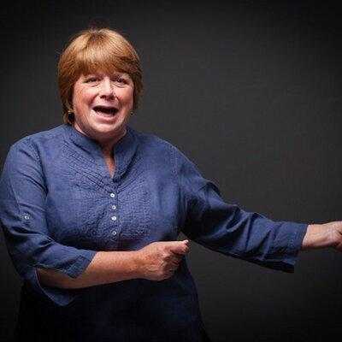
Ann Stott

Over the last 25 years I have passed on my love of singing to countless children and young people, as an educational practitioner and more recently as a freelance music educator.
My career in education began in Early Years settings and I have seen many changes from Stepping Stones through to the Early Years Foundation Stage Statutory Framework in place today.
I am a skilled vocal trainer and workshop leader, drawing on my educational experiences, imagination and sense of fun, to provide tailored sessions for a variety of Early Years settings.
I believe passionately that singing and music should be fully inclusive.

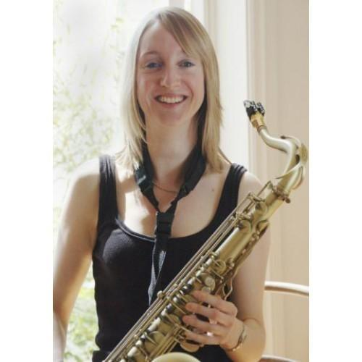
Emily Garrod
I am primarily an instrumentalist and studied classical clarinet and jazz saxophone as an under and then post graduate student. I have been teaching woodwind for over 10 years and my love of performance has led me to play with many musicians from various backgrounds and in several ensembles including “The National Saxophone Choir of Great Britain” (with whom I toured in Europe and performed extensively across England and Scotland) and the Malbec Clarinet Quartet. My interest in working in Early Years music started about ten years ago when I took a course run by Susan Young. I was inspired by my fellow course members and found that I loved the energy, diversity and improvisatory nature of the work. It is exciting to be part of the new Early Years team for the Cornwall Music Service Trust and am loving working with very young children at an age where music is such an incredible source of communication, fun, learning and comfort to them.

THE PROJECT - THE SHAPE OF DELIVERY - TAKE ART EXPECTATIONS

The 20 week project delivered by Ann and Emily began with an initial observation session.
Ann arrived to meet the parents and children at the beginning of each session.
Emily joined Ann an hour later.
The project included a 30 minute Adult Led section. This was initially delivered by the Music Leaders but as the weeks progressed the Early Years practitioners increased their input.
The Music Leaders created an environment to encourage and support the children’s innate musicality. This gave the children the opportunity to react, respond and communicate through a variety of musical mediums.
The Music Leaders and Early Years practitioners observed and gathered data.

Our aims and hopes for the outcomes of the project.

- To have an impact on the development of communication within the setting.
- To increase the confidence of the practitioners in recognising children’s innate musicality.
- To encourage the use of spontaneous music making in an improvised manner, moving music away from music only being a planned activity.
- To leave a legacy within the setting, providing ideas and resources to be used long term.

GETTING STARTED.

- We made time every session to discuss musical observations and the project in general with the Early Years Practitioners. They filmed our adult led activities in order for them to use in the future.
- The children were very receptive to our ideas and had incredible listening skills.
- Some children lacked confidence in being able to speak in front of each other and participate in group activities.
- Three children had English as an additional language.
- The children were bought a selection of outdoor percussion instruments. This gave them scope to improvise and engage in outdoor musical play. They also have a selection of small percussive musical instruments available indoors to use at all times.

Finding our inner voices.

Over the course of the project the children increased in confidence, using singing and music making to engage with their peers and with the adults involved in the weekly sessions. There was a definite shift in the responses to making and listening to music. We noticed increased use of eye contact and vocal communication from children in the group, especially in those whose communication skills were underdeveloped or had English as an additional language.

‘I spent some time with Mario (EAL) who has hardly any English and taps your arm for attention but also whistles. He was looking at a picture of a snake. I ran my finger over the snake shape whilst making a “ssss” sound, he copied me. Then he began to count objects in the picture, “1, 2”. I took some pens out of the pot on the table where we were sitting and counted them “1 -5” singing each number and rising in pitch from 1 – 5. Mario began to sing with me. We were joined by Rosie who joined in the singing too. The children then took turns to singing 1 – 5, they also increased their pitch slightly as they counted. I then initiated singing, “I am Ann, hello Mario…” this encouraged the children to sing their names, then we changed the lyric to “I am Ann, I am Mario, I am Rosie” as we took turns to sing our names. The children gave each other eye contact as they listened to each others turn.’

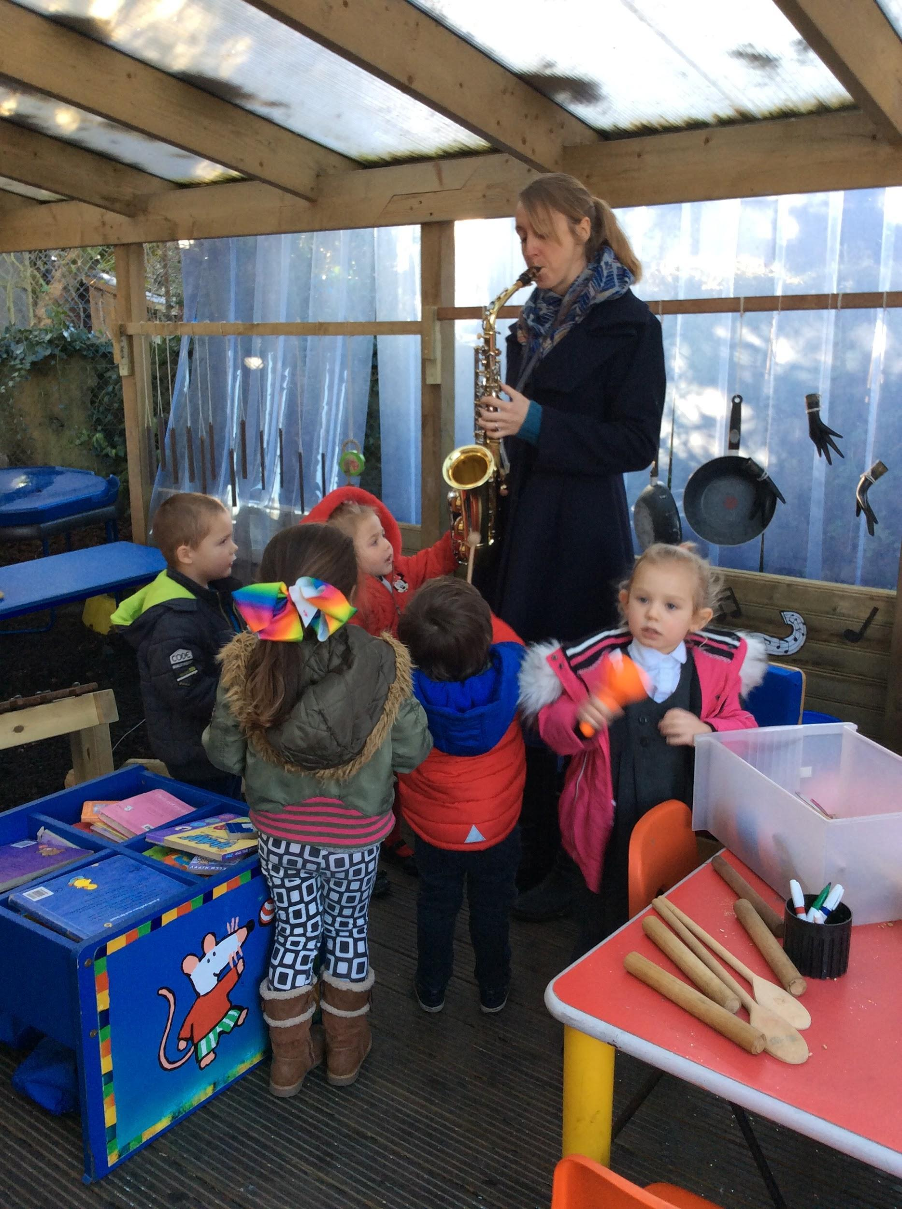

The children enjoyed interacting and experimenting with the sights and sounds of the Clarinet, Saxophone and Djembe,taken in by Emily and Ann, opening up a whole new world of experience to them. The children were very quick to understand the importance of looking after the instruments.

‘Tommy, Brooklyn, Rosie H, Jeffrey, Scarlet and Zara were very interested in the saxophone outside. They enjoyed touching the keys. Tommy brought a drum over to play along. He created a pulse for me to join in.’

In the Adult Led activities the children and nursery practitioners learned new songs and activities, the children adapted some of the songs and activities in their play.

“The children had picked up on the start/stop activity from last week’s adult led session and were using Start and Stop in their play and other activities, making up their signs eg. Raising hands for Stop, lowering hands to Start.’

As the weeks went by we found the children built up relationships with each other and the adults in the sessions. They shared instruments and played collaboratively, confident to show others their ideas.

‘In the free flow session Tommy played the harmonica, he was very confident and created his own rhythm which he played for quite a long time, he came over to myself and Emily to show his playing and then showed how he could play low notes and high notes, there was a lot of eye contact from him (this is a huge step for this child) and he offered the instrument to me to play, I played his rhythm. We took turns in creating a “musical conversation.”
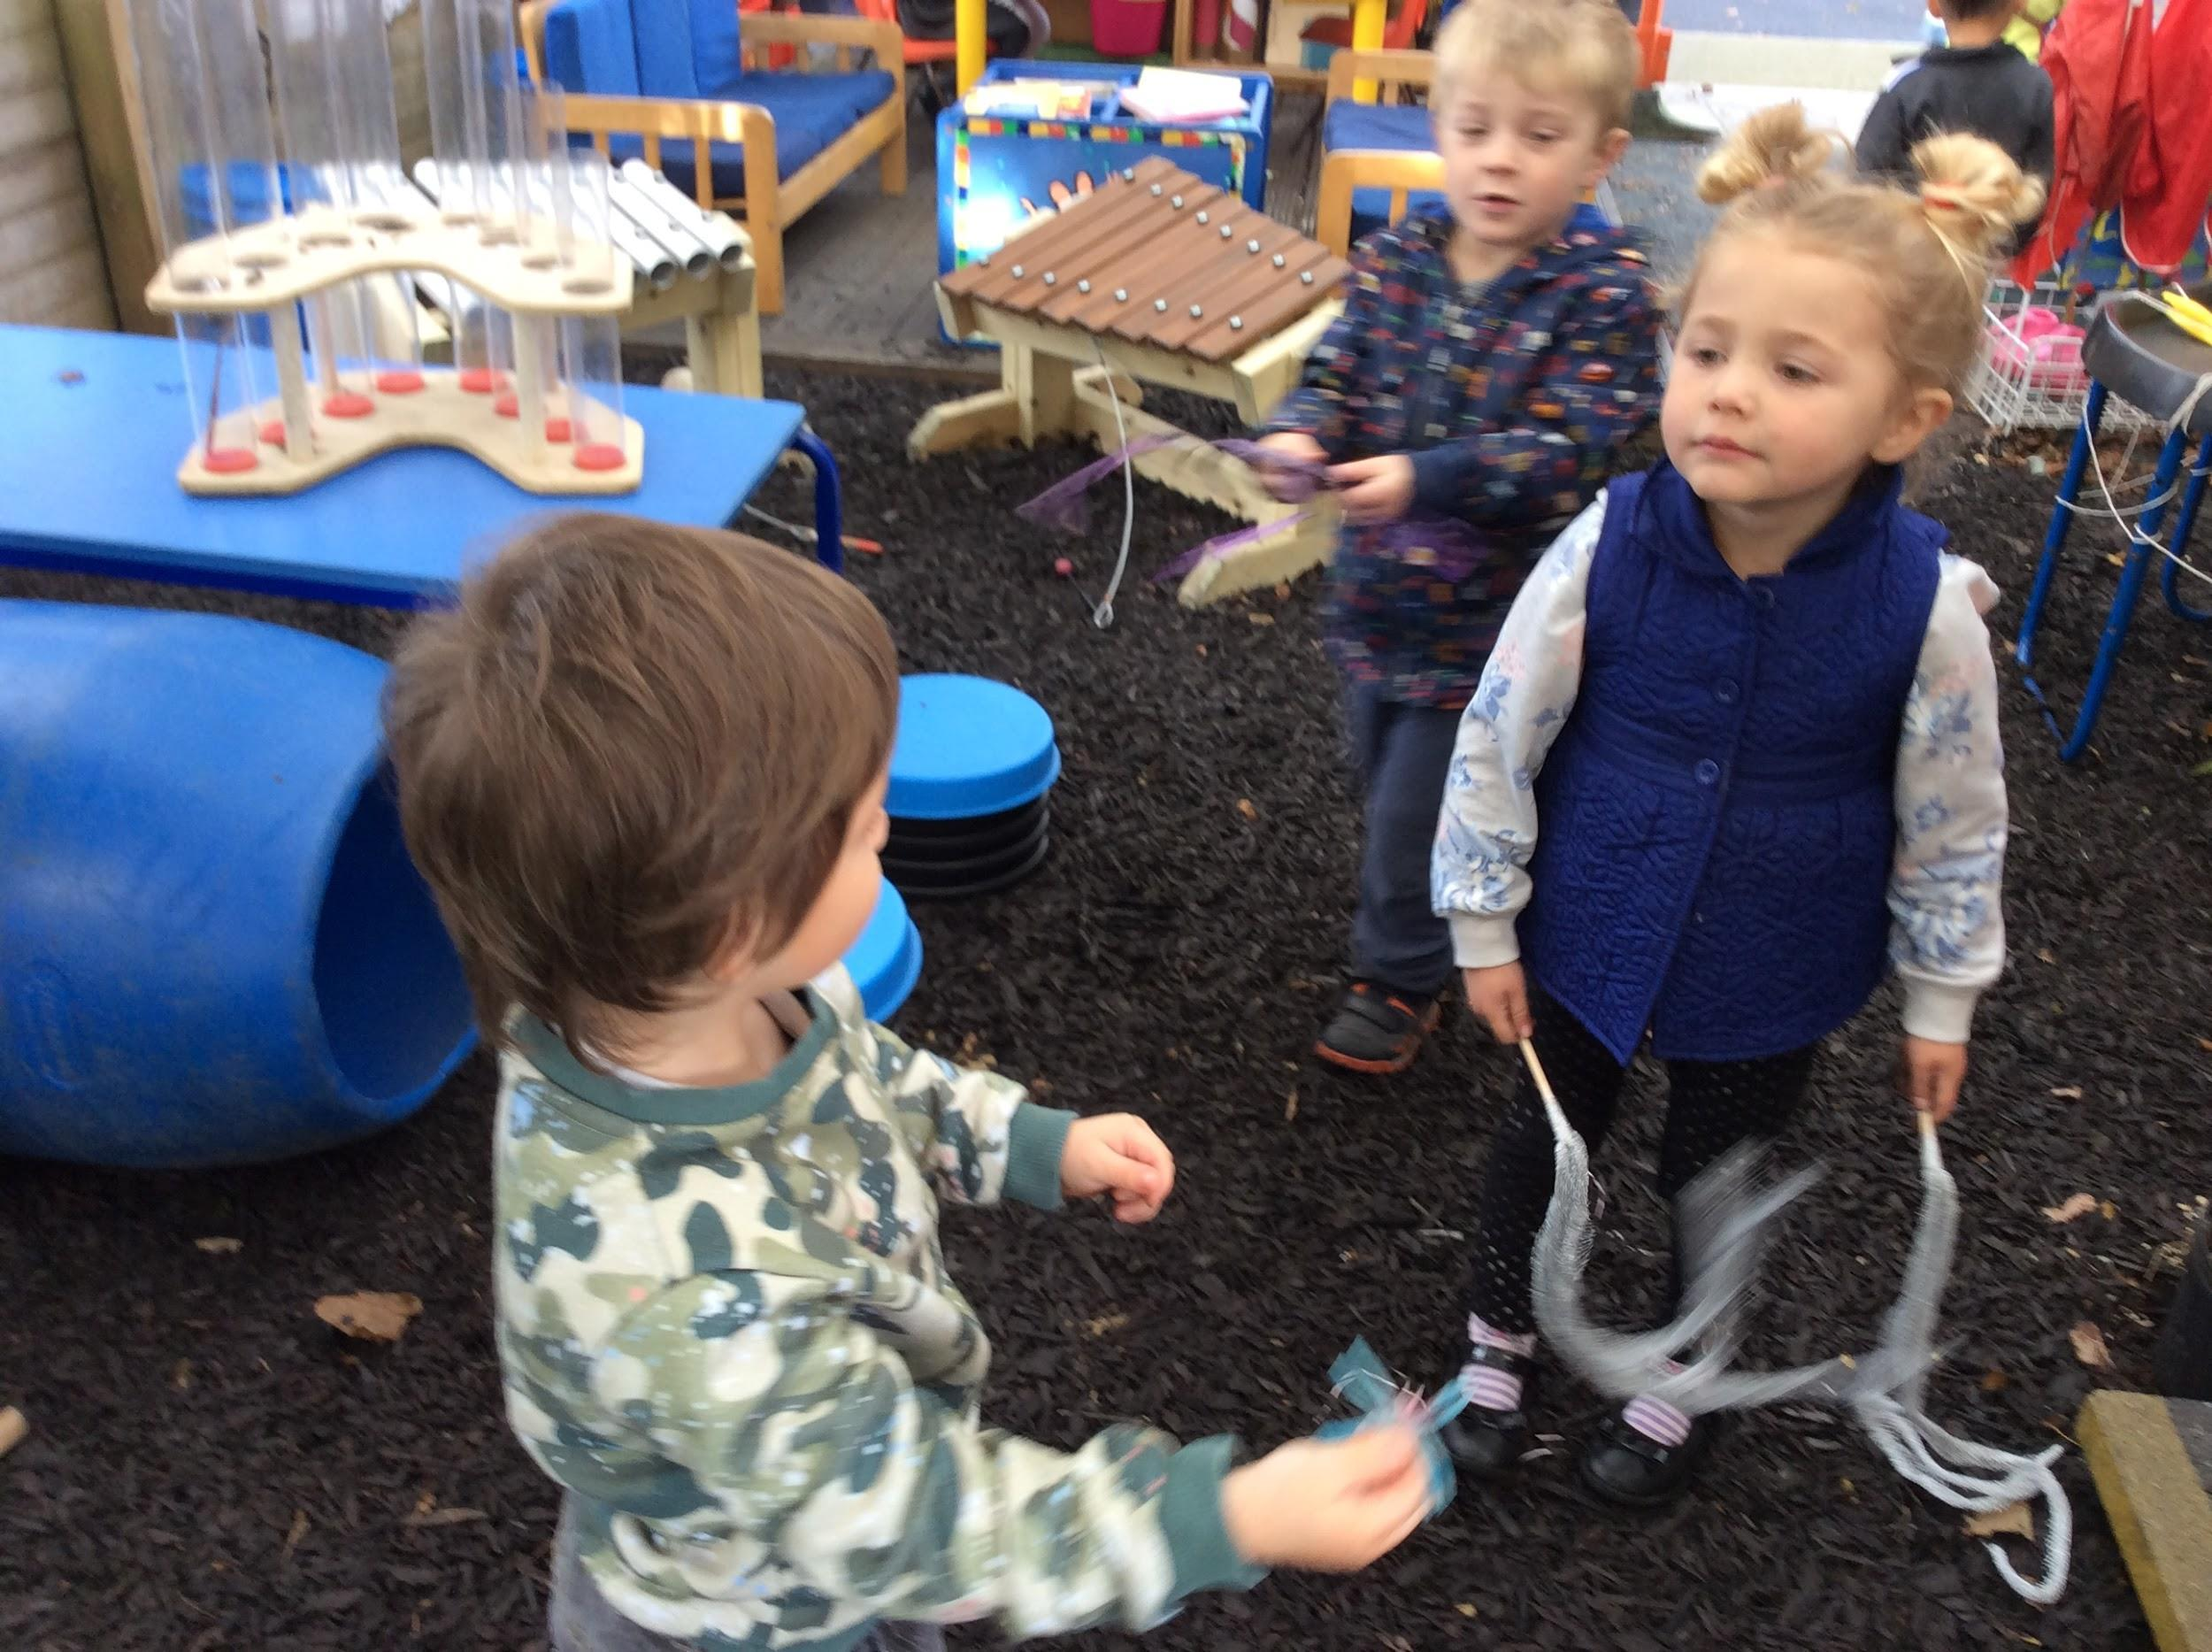

‘Tommy, Stanley and Scarlet– Super eye contact as they played with a wand and made a toy spider disappear and reappear. Tommy had previously been very quiet and unable to make eye contact with staff or peers so this is a huge step in his communication skills.’

Some children were happy to lead the group in singing the new songs they had learned during the project. We noticed increasingly they tapped, moved and rocked to the pulse with self assurance. At the start the children were nervous about singing by themselves, but by the end of the project most were happy with solo singing.

‘ Zara asked to do the Cobbler song again. She also improvised/composed a song for us to sing.’

‘Zara pitch matched the highest note of “Chest, chest, knee toe”, a new song to her, introduced during the adult led session.’

‘Zara, Rosie and Scarlet are very familiar with some of the songs and are happy to sing the songs to the others – taking a lead. Zara and Scarlet in particular.’

‘Scarlet sang” Cobbler, cobbler” as a solo completely on pitch!’

‘Harvey watched the other children interacting with the Djembe but was reluctant to join in, I took the Djembe over to where he was sitting, he gradually stroked and tickled the surface. He was playing with a “Flower Construction” set. We placed a few of the flowers on the drum skin to see what they did when we tapped the skin. Tommy joined in with Harvey to make the “flowers” jump.
(Both of these children have confidence issues which impact on their communication skills, it was great to see them interacting with the Djembe and with each other.)’
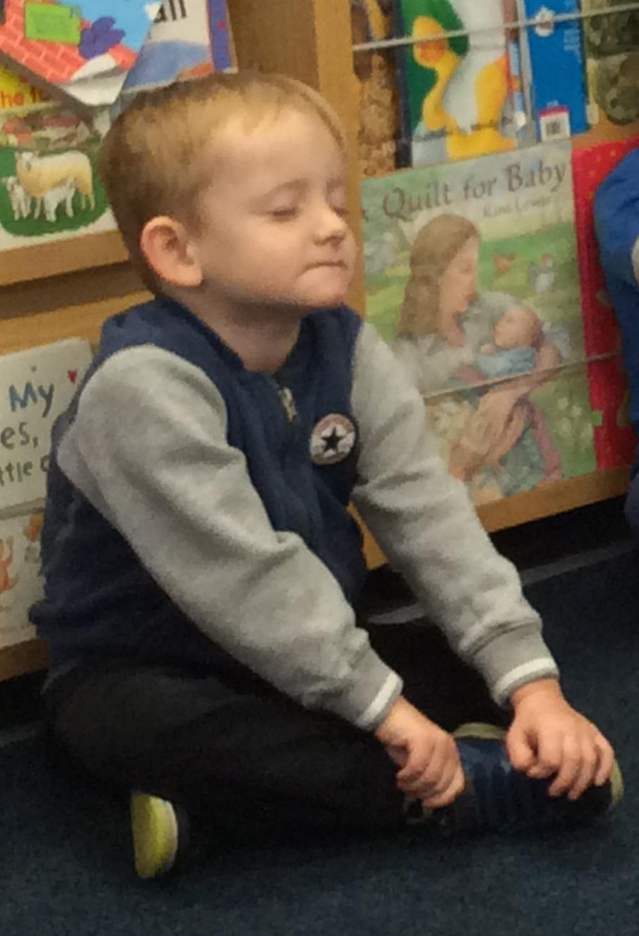

“Harvey enjoyed the warm down. I played a jazz saxophone ballad from the cd. He sat with his eyes closed for the whole piece and had a huge smile on his face. He was totally absorbed in the music and seemed very relaxed and content. A real “wow” moment for me as he is a child that doesn’t often join in and lacks confidence.”

‘The children enjoyed passing around The Snowman Toy and made some lovely sounds for Wind, Walking (using their fingers, tapping on the carpet) and Fireworks. Harvey made a really loud “BANG!” sound, showing real confidence. He then told the group that his Daddy had some fireworks, this is a marked improvement in his communication skills as he is usually very reticent.’

‘There was a lovely moment before the adult led where Scarlet started drumming (spontaneously). She was joined by Rosie, Brooklyn and Stanley and they all played together. Brooklyn sang whilst the others used hand held percussion. They were all moving in time with the music- Tommy enjoyed this idea and came over, also making movements in time to the music. Stanley then kept a steady beat on the claves and marched outside. We all followed, marching in time.’

Tommy had been given a card by one of the other children, I suggested we put it in his bag so he didn’t lose it. He showed me his bag on the peg, I asked him if I should put it in the small part of his bag or the big part of his bag, he said “Bish Ba” then he copied me when I said “Big Bag”. (This is the first time he has vocally indicated anything to me! WOW!)
Tommy continued to be quite talkative to both Emily and myself during our play with him, even indicating when he needed something, when we were using Lego, “Need more wheels” DOUBLE WOW!! Emily filmed some of these interactions.

‘Tommy joined in well with “Jump Jim Joe” giving Logan, his partner eye contact as they danced together. ‘(Filmed).

Everyone Learning Together

The project was a new approach to music activities in the setting and the practitioners, music leaders and children learned together.
Kara and Michelle were surprised by the amount of musical play, we had witnessed in the session, in our initial observations.
During the following weeks Kara and Michelle kept a record of their musical observations of the children’s play, drawing on our observational notes to use as guidance.
They made really good observations about the videos that they and we took during the course of the project, including using musical terminology to describe what the children were doing. We worked as a team, using their time with us at the end of each session to review the project videos and discuss the resources used.

‘I introduced using a large scrunchy, prop, which all the staff loved and I believe Vicki is hoping to have one made for the setting as they feel it is better than a parachute.’

‘The children were fully engaged in the adult led activities for longer than the staff
anticipated.’

‘The adult led activity will replace their normal Letters and Sounds session, as the setting feel the children benefit in a similar way from our musical activities.’

All through the project the Early Years Practitioners were increasing in confidence, when leading Adult Led moments and when recognising the children’s innate musicality.

‘Brooklyn instigated singing “5 Little Firemen”, some of the other children also wanted to sing it. Kara led singing the song to share it with us. She sang clearly and confidently.’

“Michelle was confident to lead a group when we split into 2 groups for Cobbler, cobbler. - Call and Response exercise’.

‘Both Kara and Michelle are noticing the children’s musical play, more and are able to describe and discuss it with us. They are becoming more confident about identifying the children’s innate musicality and using musical terminology to describe their interactions.

The parents too were noticing the difference the project had on their children and how much they enjoyed the music activities.

‘I had a conversation with Zara’s mum to thank her for, now, giving permission to use images for the conference etc. ”She is doing so well with the music, I wanted to show what she can do.” “She sings all the time.” “She makes up songs all the time” (at home).’

‘Stanley’s mum is dropping a day at Nursery but will not drop Wednesdays because he loves the music.’

Outcomes and Conclusion

Throughout the project Ann and Emily have introduced the Early Years Practitioners to a variety of resources, Kodaly based songs and activities, a large scrunchy, using lycra with soft toys and prompt cards for the songs, which can be used in the setting in the future. They have left a legacy of resources, on which the setting can build, with their increased confidence, in music making with the children in their care.

Michelle

‘On a Wednesday morning when Ann and Emily come to see us we all look forward to seeing them and joining in with new songs and ideas they give us. The children are more confident in joining in and using the songs they have learned and use them with in their play and around the setting inside and outside.
I feel that I have learnt from Ann and Emily and am confident in using it within the setting and planning it on our weekly planning and observations.’
Kara
‘On a Wednesday Ann and Emily have been attending the setting to work with Myself, Michelle and the children. The children look forward to this session and I feel it has enabled some to grow in confidence. I also feel I have grown in confidence when leading carpet time, and am now able to recognise and use some of the things I have learned within my observations of new working practice.’

Prior to starting the project in September 2017 data reflected that 32% of the children were below expectations for communication and language in accordance to EYFS.

By December 2017, 13 weeks into the 20 week project, the data review showed that this figure had dropped by 9% to 23% below expectations.

Overall 88% of the children show progress in Communication & Language, 6% show a whole point progress which is significant. Every child made progress in at least one or more areas of communication when broken down into separate categories (Listening & Attention 52%, 82% Understanding, 65% Speaking).

‘One child who is very quiet, on the SALT programme (need was identified but referral took so long to go through that was not doing at time of start of programme). If progress continues at rate has been doing so he won't need to be on for long before sign off.’

‘It was rather lovely as obviously those that were already as expected have enjoyed the programme, grown in confidence and probably taken on a leadership/mentor role.’

‘Those quieter and below expected are all showing progress in more than one area of CL.’

The above data and comments from the Nursery Manager show the overall impact of the project on the development of communication in the setting and our many observations and videos have provided a great deal of evidence to support these findings.
Music has supported the children in the setting who were achieving below the expected norms but has also impacted on on the growth in confidence in those children on target within the EYFS expectations.
Through sharing their musical experiences with their peers those children in the setting who lacked confidence are now able to speak in front of each other and participate in group activities. They are able to communicate their thoughts and feelings with each other and with the adults around them by vocal and musical means. The improvisational elements of the project encouraged the children to engage in “musical conversations” with each other and increased their confidence in showing their peers and the adults in the setting their own musical achievements.

